1. Circuit Schematic

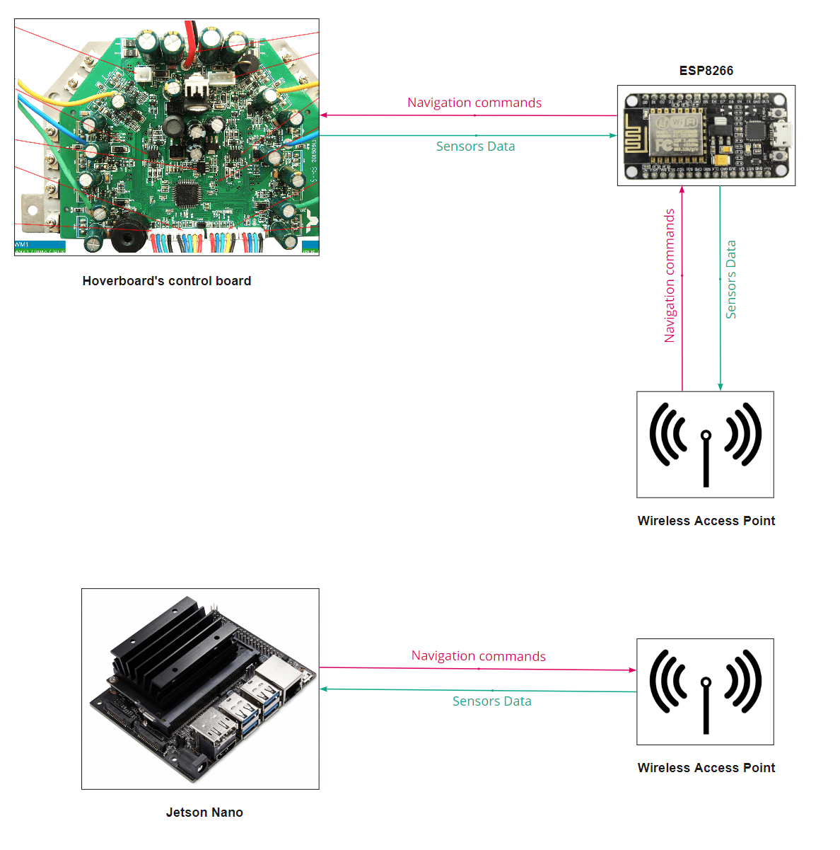The green arrows represent the flow of data from the sensors. As shown in the figure the sensors data flow from the hoverboard to a Wi-Fi module and then to the Jetson Nano. The data is then processed by the Jetson nano and using the algorithms for navigation and obstacle avoidance it sends the commands though the chain to the hoverboard

Figure 1 - Data flow schematic

1. Mechanical specification of the cart

The figure below shows a SolidWorks model of the cart after adding the changes discussed in maturing the baseline design. The cart is a rectangular prism with the dimensions (L×W×H) (70×50×20 cm)

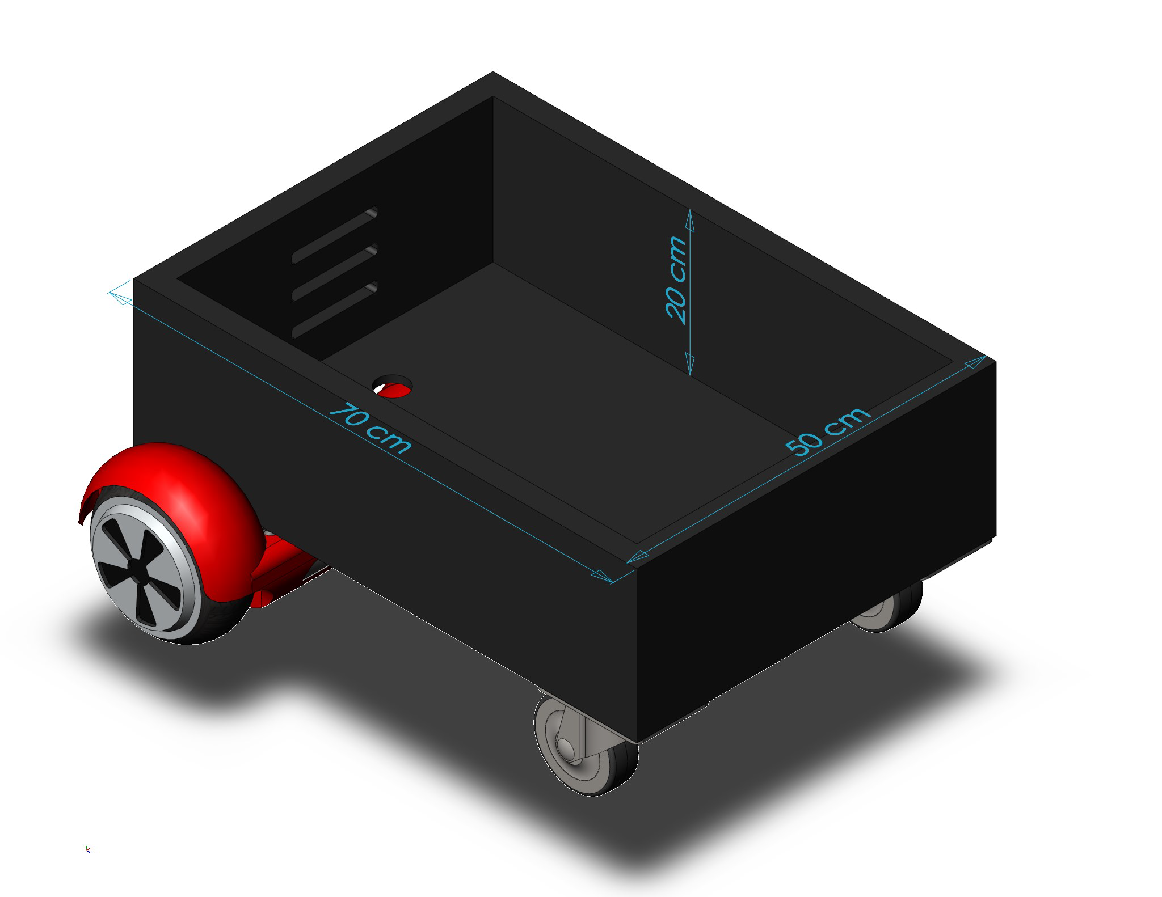

Figure - SolidWorks model of matured design

1. Technical Aspects

Perhaps the most critical musts for our project are the ability to carry a weight within **80 kg** and that the artifact must be able to operate within **5 km/h**. To be able to satisfy those conditions we need powerful motors. Different hoverboards might have slightly different specifications but generally, the motors have a power of about **350 W** at **36 V** and can speed at speeds of up to **700 rpm** at higher voltages. For the speed requirement, hoverboards can operate at about **9.6 km/h** to **16 km/h** in faster models which is more than enough in our case. The wheels used in hoverboards have a diameter of about **15-25** **cm**. [1]

1. Simulation Results

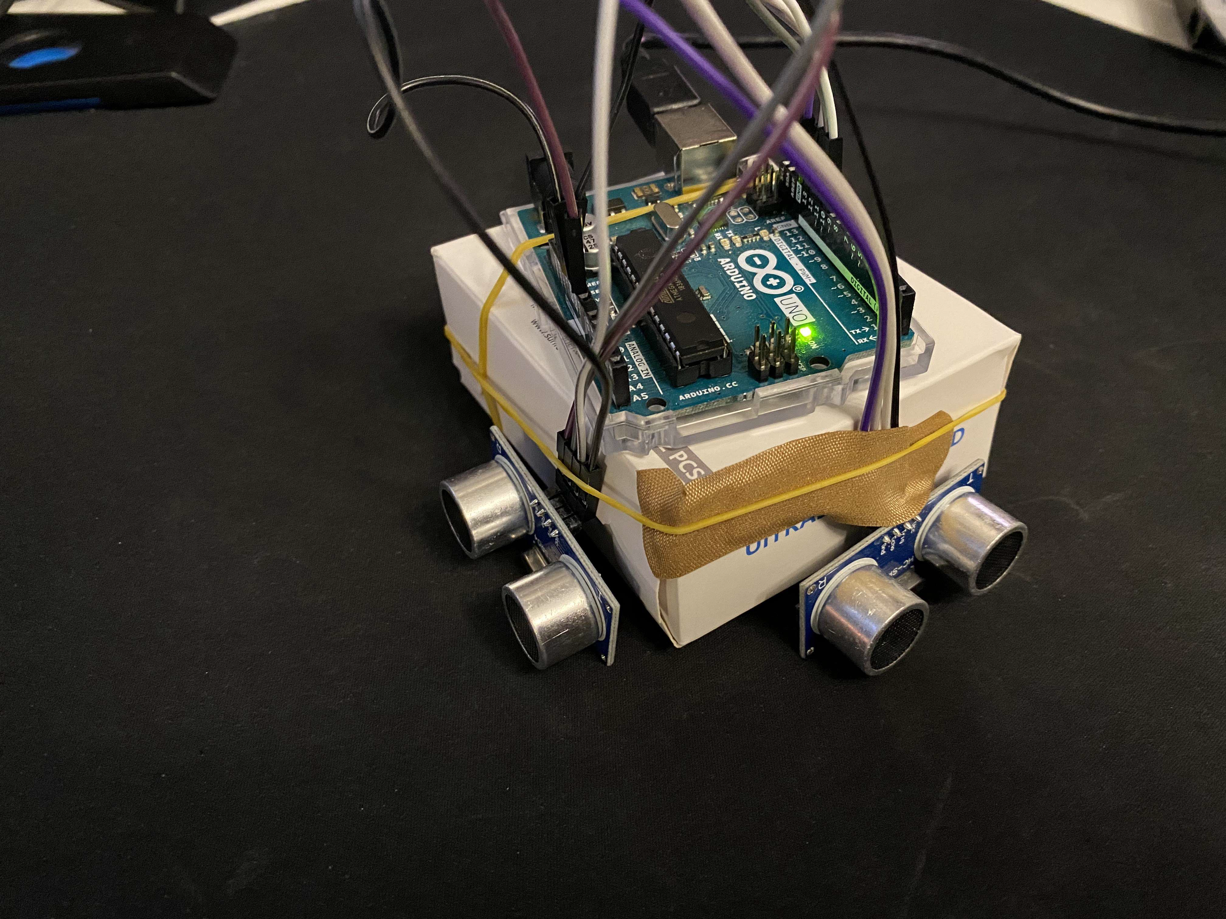For simulation we made a localization program using MATLAB. We connected the Arduino to MATLAB, and we used ultrasonic sensors to measure distance and find out the location of the robot relative to the “walls” or in our case, the box’s boundaries.

Figure - Localization prototype

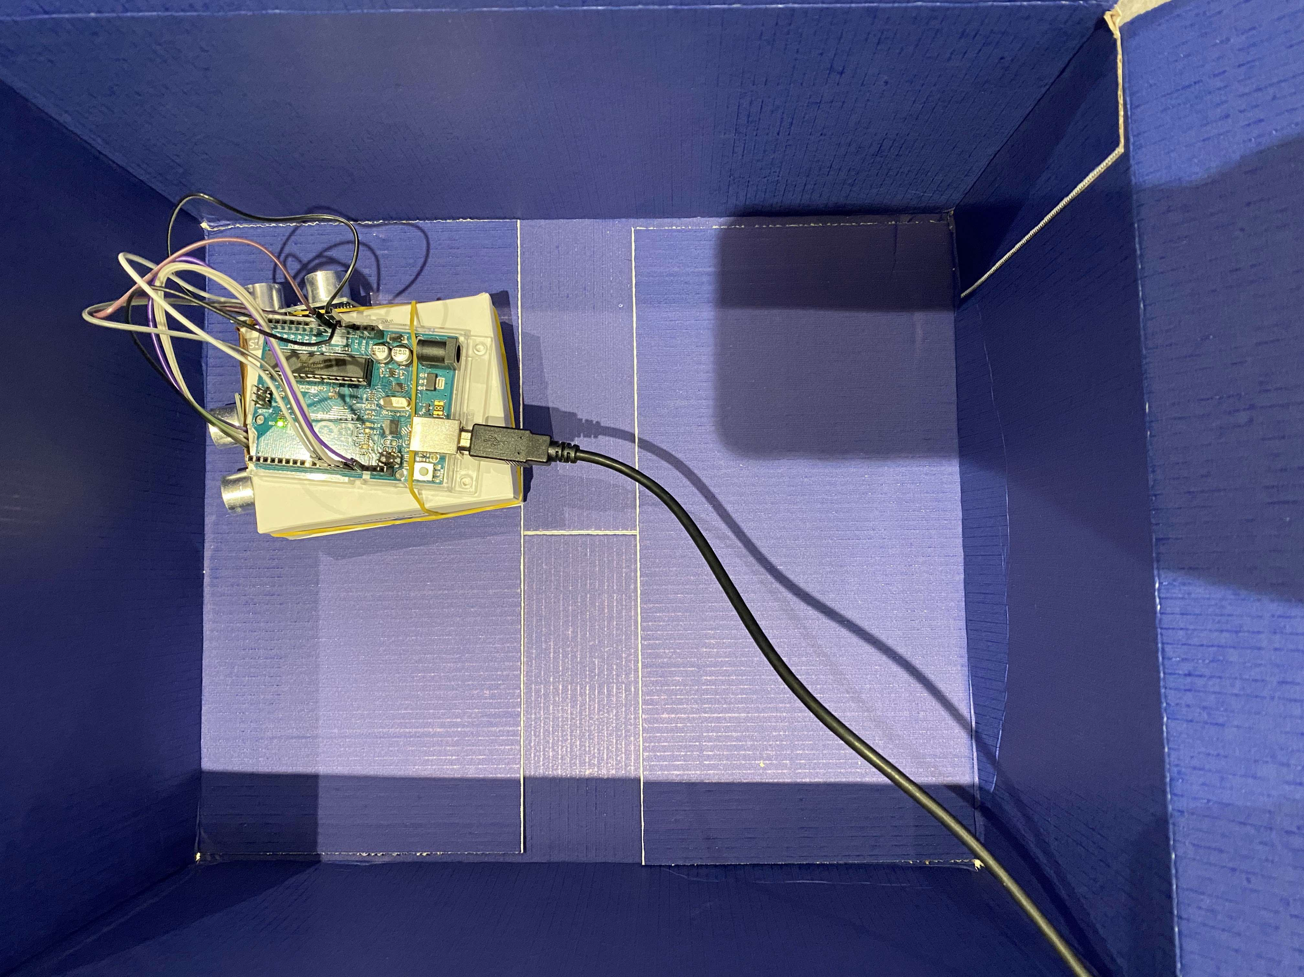The prototype uses 2 ultrasonic sensors 1 for each coordinate in the xy-plane.

Figure - Box used in localization simulation

We placed the prototype in a box and started the program. Giving us the result shown in the figure below.

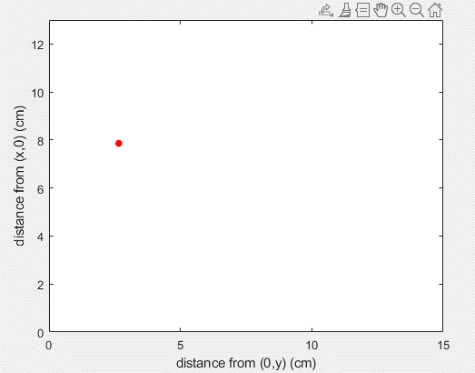

Figure - Resultant plot in MATLAB

The red dot represents the prototype, and the boundaries of the plot represent the walls of the box. The plot is dynamic, meaning that the red dot moves with the movement of the prototype. It is not just a snapshot of the location at a particular moment.